As of February 2019, FFx40, FFx40.Rx, FF240-IP-2, FF240-IP-2.Rx, software version 5.1.6.3 implements a new software upgrade script. This script has added protections, allowing for a more reliable software upgrade process. If the FaxFinder system does not have enough free space to download the new version of software (before un-installing the old) or if there is a problem downloading new files, the script will abort, and the upgrade process will not proceed (making no changes to the system).

For units running software version 5.1.6.2 or older, the new script will have to be downloaded from Multi-Tech’s FTP site and then uploaded into your FaxFinder unit before it can interact with the update server at Multi-Tech and proceed with any software upgrade.

If your unit is not running the new upgrade script, you will see the following error:

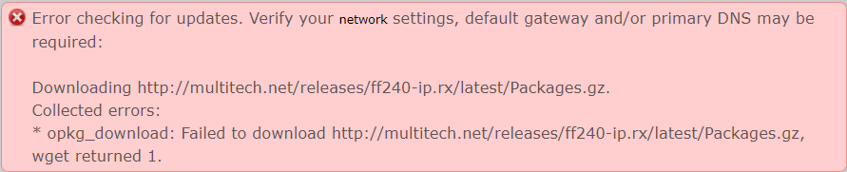

The above error message will reflect the model number of your unit (in this case this came from an FF240-IP.rx model).

Here is the procedure for updating units running software version 5.1.6.2 or older.

Download the file “ffupgrade” to your workstation. The file is downloaded from here: ftp://ftp.multitech.com/faxfinder/res5095129/ Use an FTP client to connect to the site for downloading it (anonymous login). When downloading the script via FTP, make sure the transfer type is set to “Binary” before invoking the down load. The file is 5519 bytes in size.

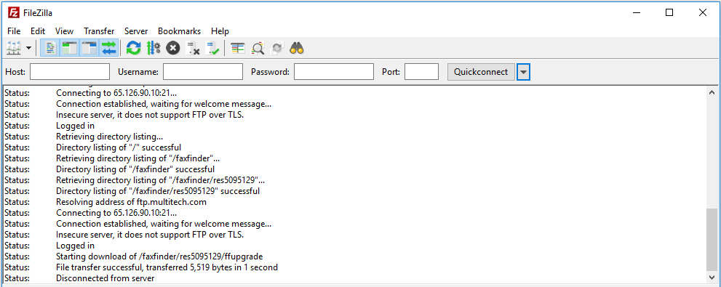
Once the file is downloaded to your workstastion/PC, use an SCP client like WinSCP to connect to your FaxFinder unit. We recommend renaming the original ffupgrade script in your unit before uploading the new one, but it is okay to over write the original.

The following process uses Winscp to upload the file and modify existing file name and attributes of the new file.

Copy the new ffupgrade file into the /usr/local/bin/ directory of your FaxFinder.

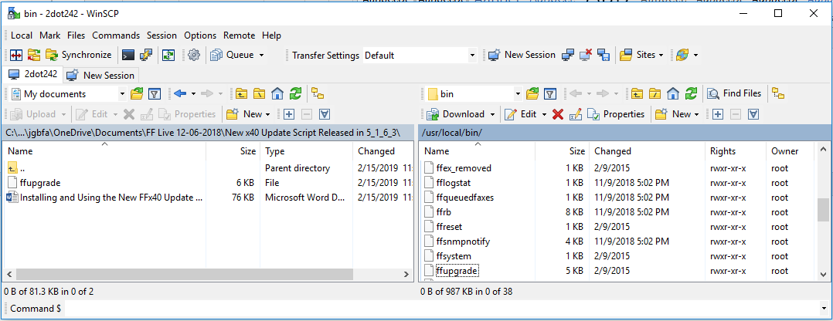

The above screen shot shows winscp connected to a FaxFinder with the original ffupgrade script in the /usr/local/bin/ directory.

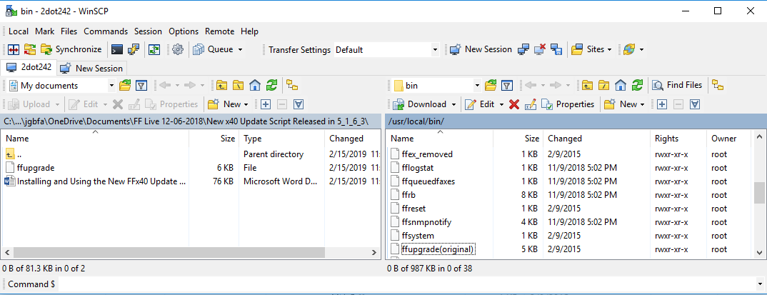

The above screen shot shows the original file renamed to “ffupgrade(original)”. Using winscp right click on the file and select “rename”.
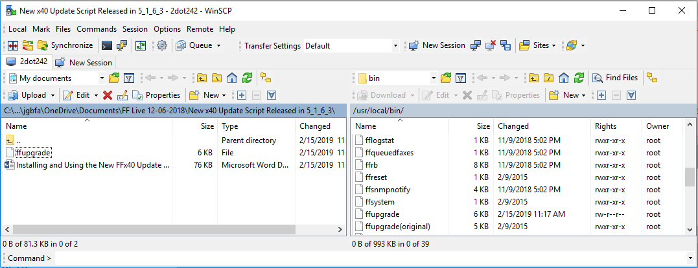

The above screen shot shows the new version copied in (note the file size is slightly larger). Also note that the file does not have executable rights.

Right click on the new ffupgrade file and select properties. Then check each box with the “x” executable attribute and click “OK”.

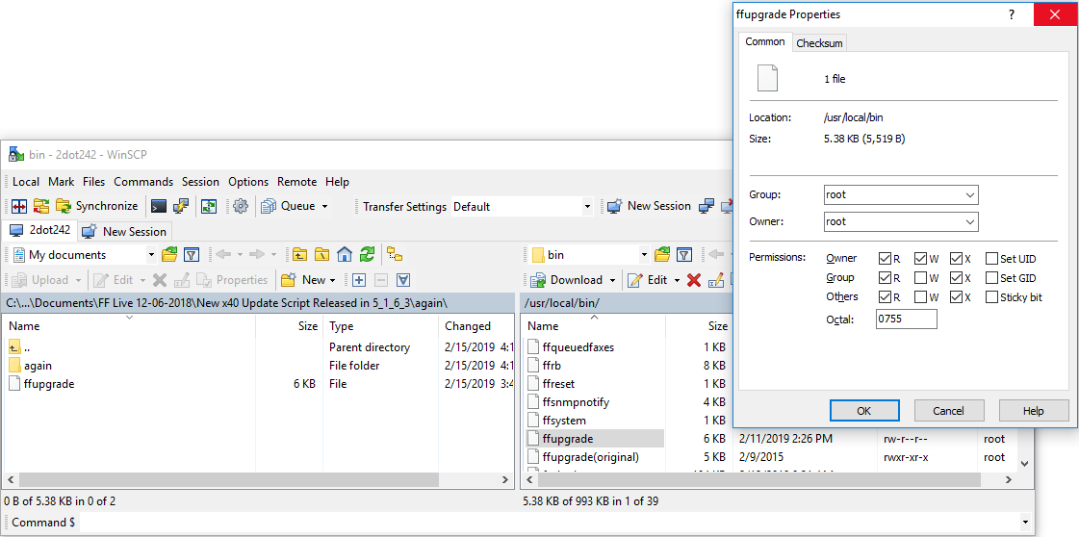

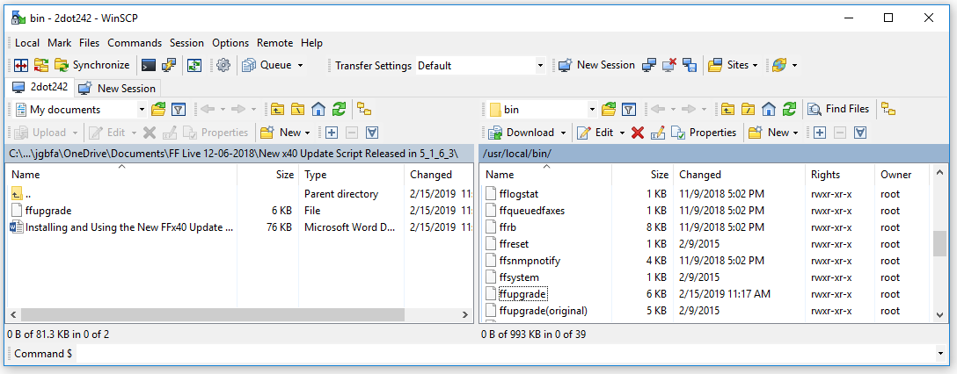

The above screen shot shows the new file uploaded with the correct attributes set.

Next, Log in as admin into your FFserver via the WEB interface and go to System Configuration -> Software Update menu. Click on the “Default” button.

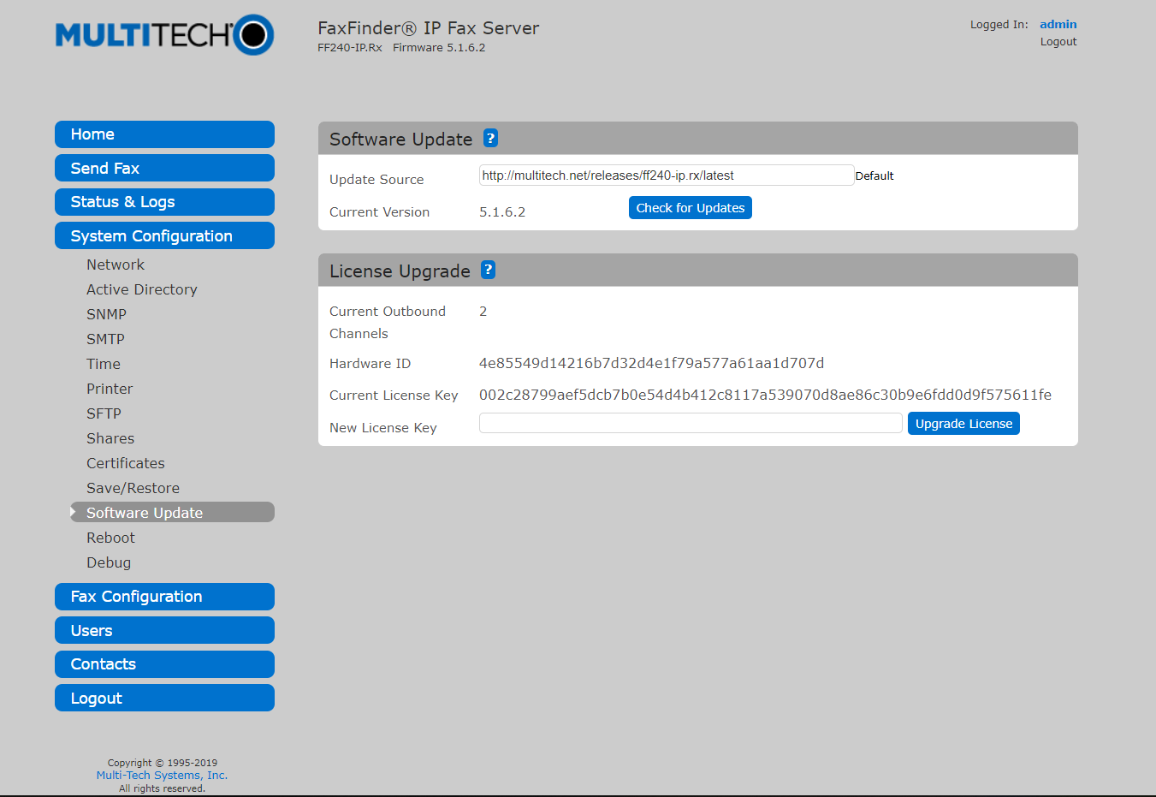

The above screen shot shows the update source (path) for the FF240-IP.Rx models after clicking on ”default”. Software versions 5.1.6.2 and older default the path to look in the “latest” folder on multitech.net.
Next Change the path from “latest” to “current” path (this is the new path needed for use with the new upgrade script) and then click on “Check for Updates”.

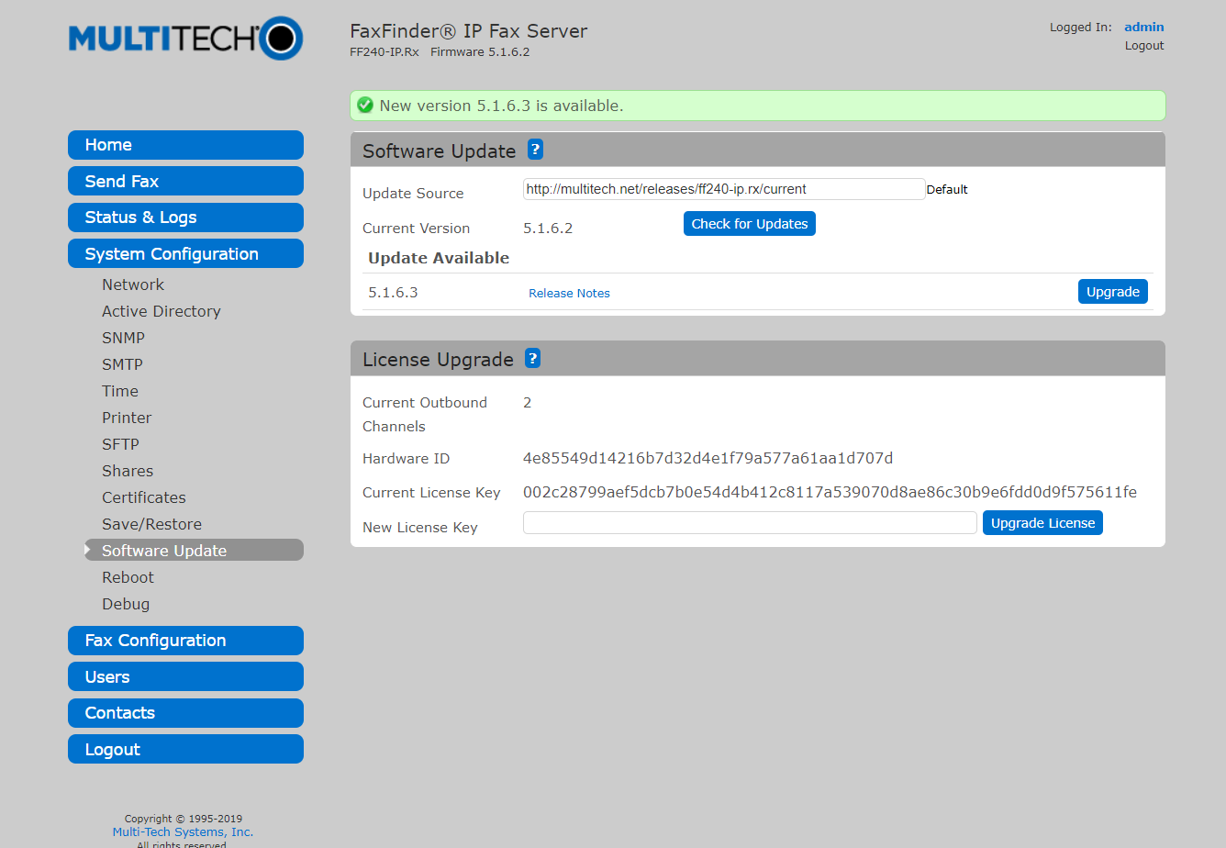

The above screen shot shows the update source modified to “current” and the results after checking for updates.

Next click on the Upgrade button. When the unit comes back (about 6 minutes later) it will running version 5.1.6.3. Note the new logo and contact information on the home screen.

